ZOOCRÜ

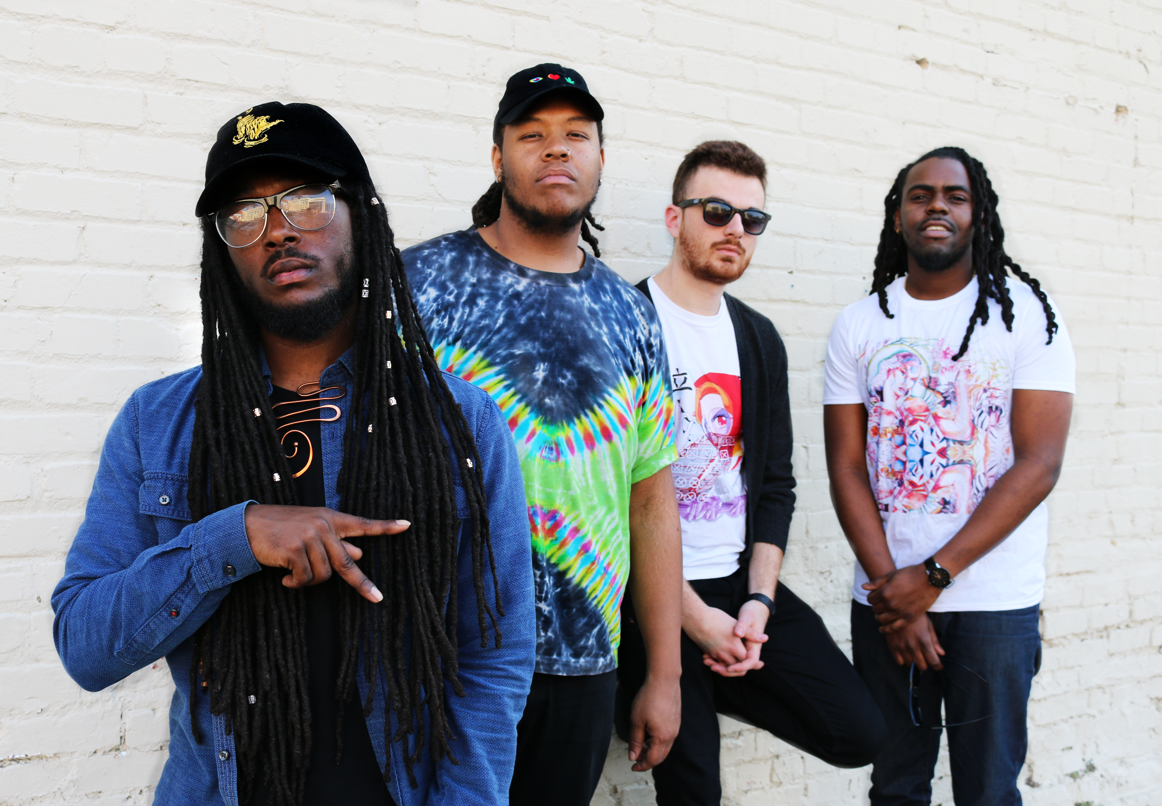

CRUBOOKING@GMAIL.COM

919-621-3792

ZOOCRUOFFICIAL.COM

Press Kit
CRUBOOKING@GMAIL.COM
516-477-8804

ZOOCRUOFFICIAL.COM
ZOOCRÜ

About
ZOO + CRÜ
noun, /zoo/ /kroo/
1. A group of individuals co-laboring together towards a common goal in their own distinct way.
2. A dope fuckin band.

ZOOCRÜ formed amidst the thriving music and arts community of Durham, North Carolina.
Common interests and experiences brought founding members Jonathan Curry, Christian
Sharp and Alan Thompson together on the campus of North Carolina Central University in
2012 for early collaborations that were fruitful, musically stimulating and set the foundations for
the group. Russell Favret was added in 2015 and as a complete unit the band has ascended
to new musical platforms.

ZOOCRÜ creates from the core belief that all American music is born from the seeds of Black
music. Drawing from this rich musical legacy, ZOOCRÜ blends all popular American genres
into a sound best described as Black American music. Jazz serves as the foundation, as all the
members are classically trained jazz musicians, and is built upon with elements of hip hop,
blues, rock and gospel. They were particularly influenced by artists such as Roy Ayers, A Tribe
Called Quest, J Dilla, Jimi Hendrix, Wu-tang Clan, Radiohead, Herbie Hancock and Miles
Davis. Infuse that with the geographic and cultural diversity that each member brings and you
have the ZOOCRÜ sound.

But it’s bigger than the music for this group. They are well aware of the moment they are living
in and believe that it is their purpose to create art that is equal parts anthem and affirmation;
sounds that heal the broken, tunes to honor the fallen and creating sonic space for all in the
Cru World Order.
CRUBOOKING@GMAIL.COM

919-621-3792

ZOOCRUOFFICIAL.COM
ZOOCRÜ

Press

"The group headlined the Off the Hook benefit at The Pinhook,
transforming the space into an otherworldly sound realm...Zoocrü
will demand serious consideration as the most debonair
band—jazz or otherwise—in the Triangle.

"As I watched their set, I admired them for their potential, their
general presence, and their taste...It'll be exciting to see where
they'll go."
CRUBOOKING@GMAIL.COM

919-621-3792

ZOOCRUOFFICIAL.COM
ZOOCRÜ

Select Performances
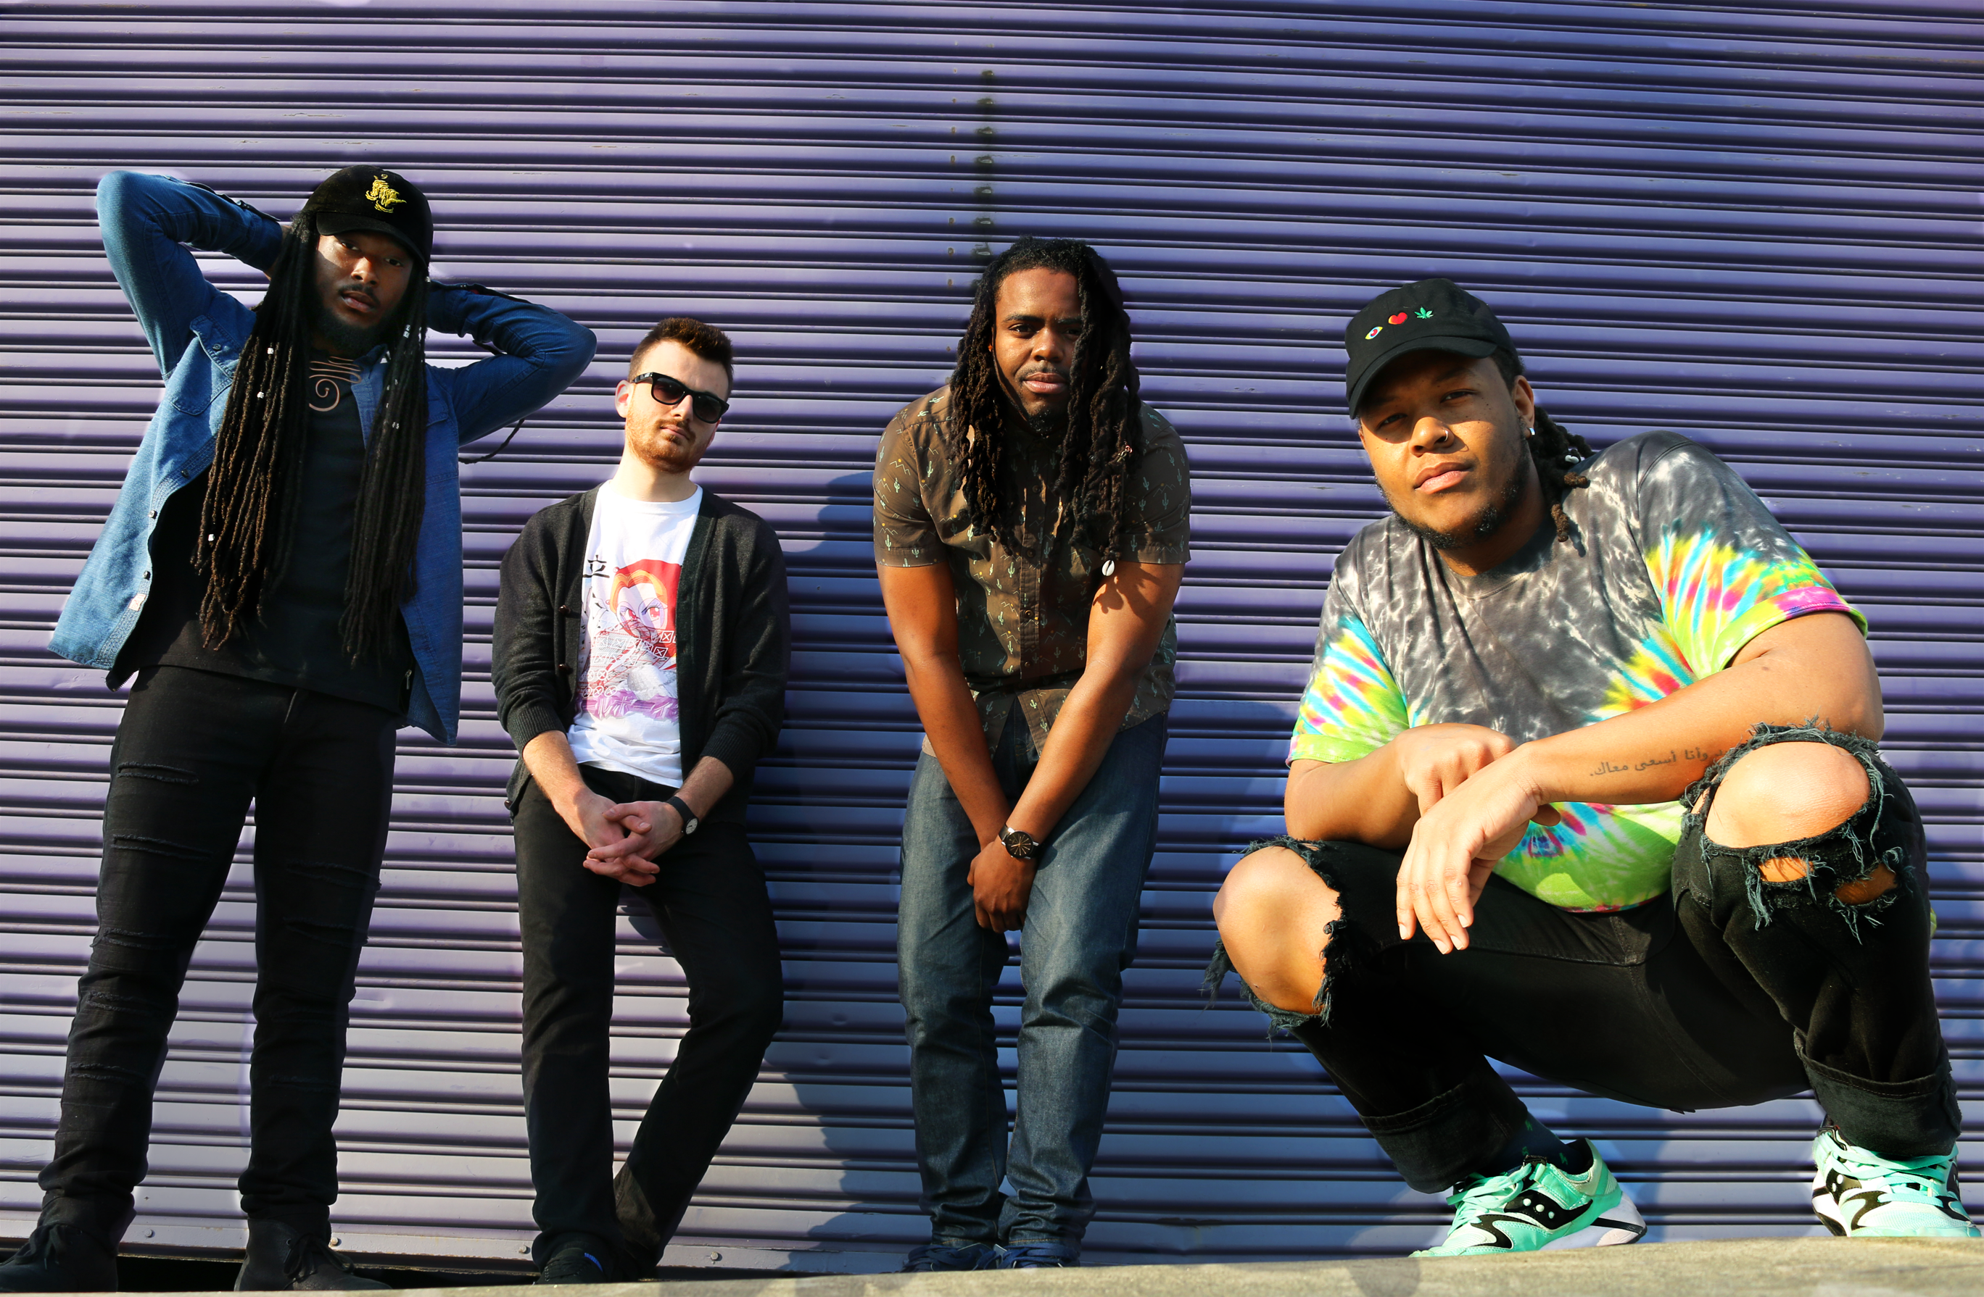
Dammit Fannie, Charlotte, NC February, 2016
Billed with Braxton Cook, Pour House June, 2016
Sold Out Album Release Party, Pinhook June, 2016
Art of Cool Festival 2014, 2015 & 2016
Billed with Masego and Goldlink, Art of Cool Festival 2017
Performed with Rakim, Art of Cool Festival 2017
Billed with Kenneth Eric Roberson, Motorco July 2017

CRUBOOKING@GMAIL.COM

919-621-3792

ZOOCRUOFFICIAL.COM

ZOOCRÜ

Media

Video:

https://www.youtube.com/watch?v=462GGYq3rpM

https://www.youtube.com/watch?v=N6LXzO7i8WE

Audio:

https://zoocru.bandcamp.com/releases

https://soundcloud.com/zoocru

https://open.spotify.com/search/results/zoocru
CRUBOOKING@GMAIL.COM

919-621-3792

ZOOCRUOFFICIAL.COM
ZOOCRÜ

Contact

For Booking and Press Requests, please email
CRUBOOKING@GMAIL.COM

Visit our website at:
ZOOCRUofficial.com
CRUBOOKING@GMAIL.COM

919-621-3792

ZOOCRUOFFICIAL.COM

